Download the Floracliff Trail Map!

1. Go to the app store and download Avenza Maps.

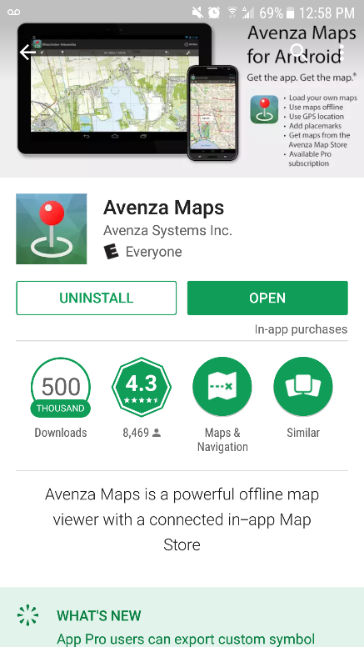

2. Open the app, and start by clicking on the “+” in the bottom right side of your screen.

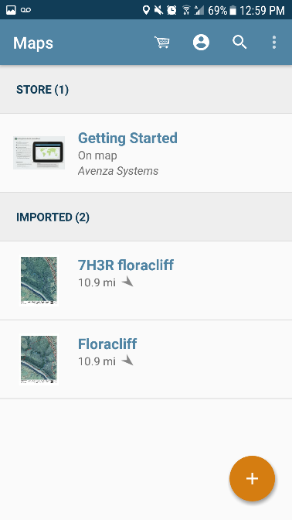

4. Select the “Download or import a map” option.

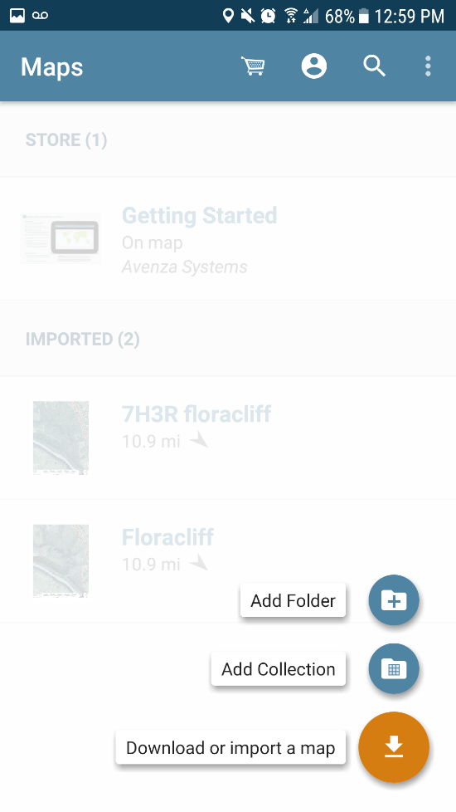

5. Then click on the QR icon in the upper right corner.

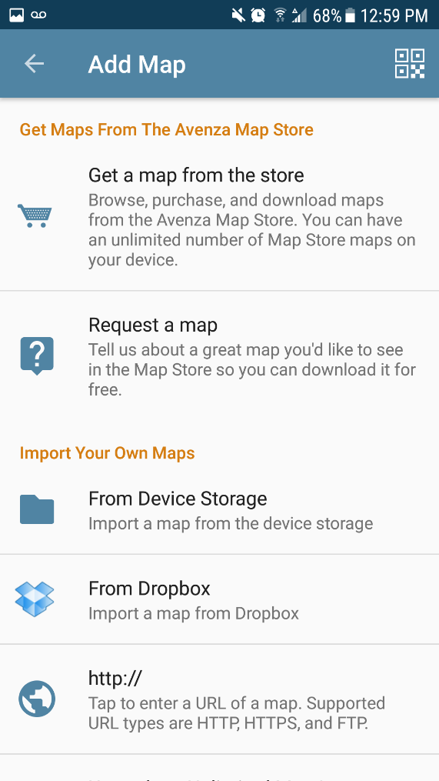

6. Scan the QR code below and then wait a minute or two for the map to upload to your Avenza Maps. The map will then be displayed under the “Imported” section on the main screen.

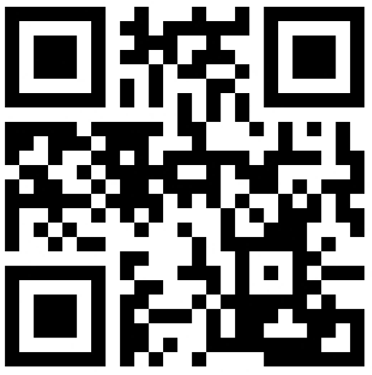

7. Click on the map, and then you can see your location at Floracliff by clicking on the location icon in the upper left corner (note: this only shows where you are on the map, if you are not within the map bounds then your location will not be displayed).

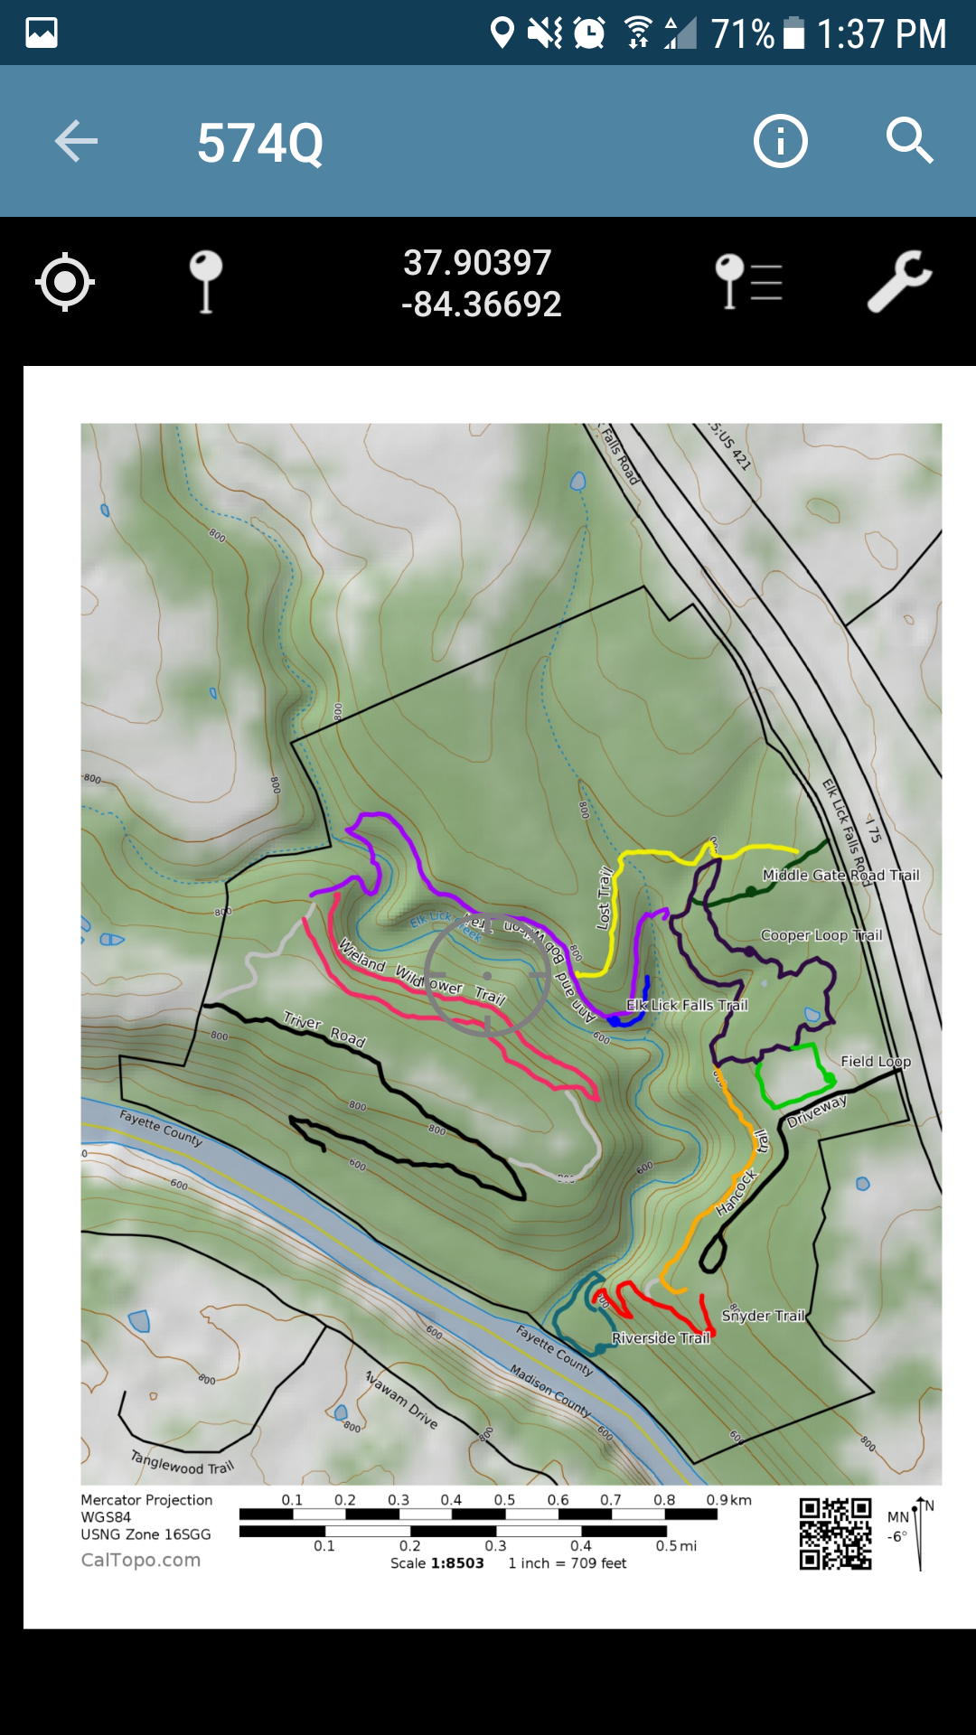

8. Enjoy hiking and seeing your location on the map! You can also drop points on the map if you find anything interesting by clicking on the pin icon in the upper left corner.

